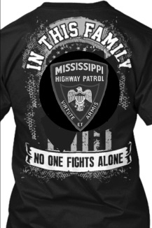
Keith Cole, F26 graduated Class 62 on March 6, 2018 and on April 11, 2018 was diagnosed with EG Junction Cancer (cancer that is located at the junction of the esophagus and stomach). The malignant tumor started from acid in stomach from ulcers and reflux. This rare cell type is diagnosed in only 1% of Americans. Trooper Cole is currently receiving treatment at MD Anderson in Houston, Texas. Doctors say he will be there a significant length of time.

T-shirt color is Black
100 % Dry Fit
Prices: Youth-XSmall, Small, Medium, Large, XLarge
Adult- XSmall, Small, Medium, Large, X-Large, XX-Large, XXX-Large- $20

Y-XSmall___Y-Small___ Y-Medium_____Y-Large____Y-XLarge____XSmall _____
Small _____ Medium _____ Large _____ X-Large _____ XX-Large____
XXX-Large_____Total $______
100% Cotton (Gildan Brand)
T-Shirt Color is Black
Prices: Youth-XSmall, Small, Medium, Large, XLarge
Adult- XSmall, Small, Medium, Large, X-Large, XX-Large, XXX-Large- $20

Y-XSmall___Y-Small___ Y-Medium_____Y-Large____Y-XLarge____XSmall _____
Small _____ Medium _____ Large _____ X-Large _____ XX-Large____
XXX-Large_____Total $______

Name: _________________________________
Address: _________________________________
Phone Number: _________________________________
Order forms must be turned into Michelle Thompson at Troop F Substation no later than June 15, 2018. Please enclose your money with your order form. Please make checks payable to Troop F Activity Fund.

